EFIT Assignment Applied Logic

Tue June 29 2021

15:30 - 17:00, R10

Teacher: Jurjus

For all exercises, deliver:

* Original puzzle
* Z3 input or Python code, ***including explanation of the clauses  
  (no screenshots please for the z3 input, either a separate .smt file, or text in a document that can be copied)***
* Z3 output (text or screenshot)
* Additional explanation of your approach

Exercise 1 – Futoshiki puzzle (10 points)

Futoshiki is a variant of Sudoku. In the futoshiki-puzzle below, it is required to fill out the grid with numbers from 1 to 6, such that each column and each row contain all 6 numbers, and such that all the inequalities in the picture are respected, as well as the numbers already provided in the picture.   
Let z3 find the solution to the puzzle below. Keep both the z3-input and z3-output clean and readable.

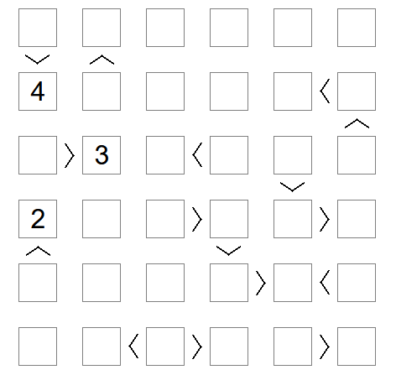

*(Source: futoshiki.org.)*

Exercise 2 - Medicine testing (10 points)

We have 7 medicines, and we have a test that can test up to 3 medicines per test-round.

Let z3 find an arrangement of 5 such test-rounds such that each medicine is tested at least twice.

*(Hint: z3 supports the (exists) quantifier.)*

*Good luck!*